RACEDAY
PART 1 — SYSTEM PLANNING AND DATABASE
Student Number: ST10466127
Module: PROG6212
Date: 4 September 2026

Section A — Entity Relationship Diagram (ERD)
The ERD contains six entities: Users, Events, Categories, Routes, Enrolments and Results. Primary keys and foreign keys are identified, and the relationships show the required one-to-many and one-to-one cardinalities.
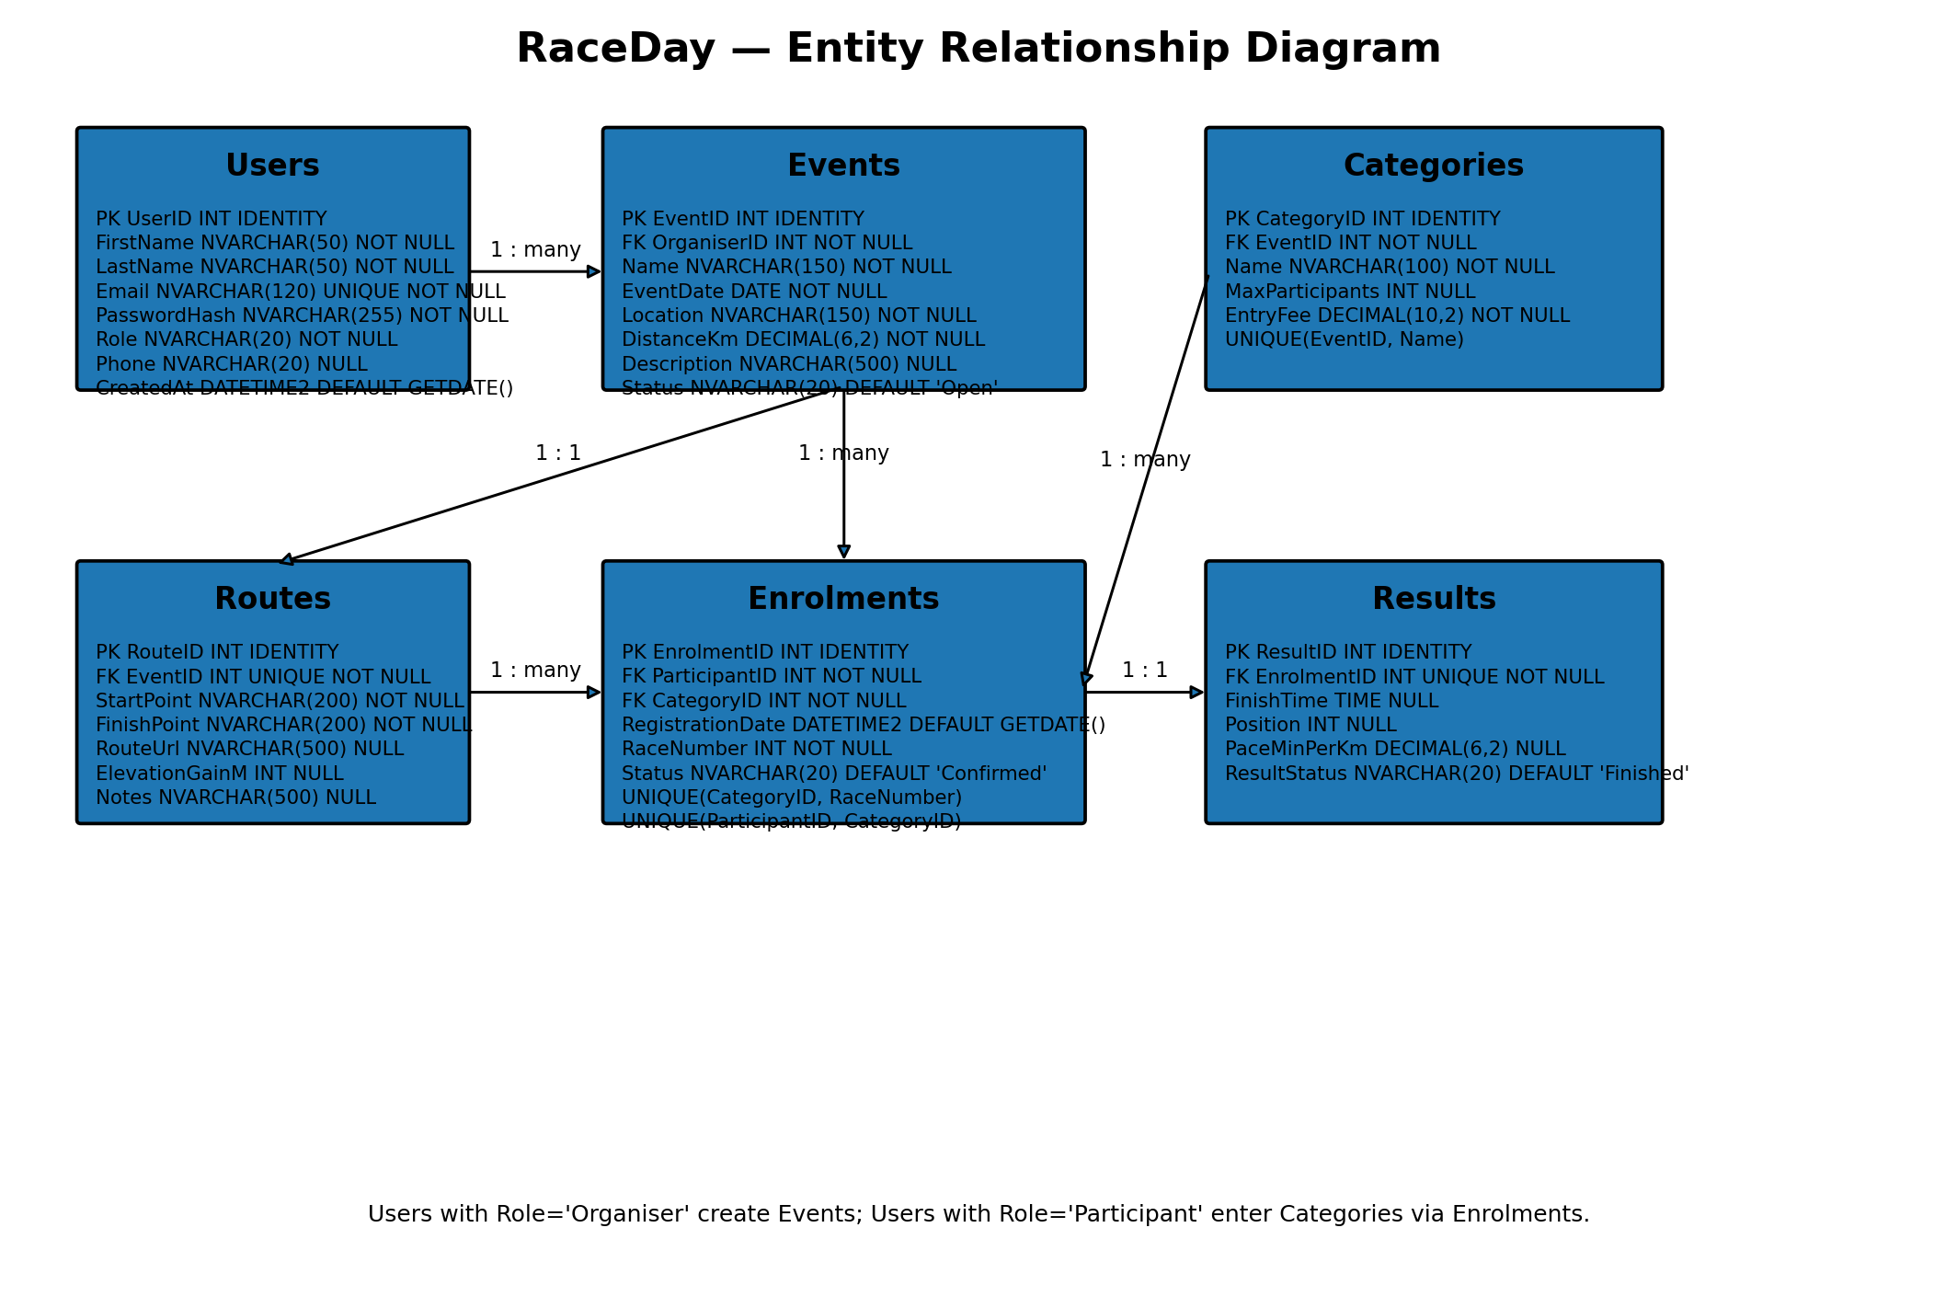

Entity descriptions
Users
Stores both organisers and participants. The Role attribute determines which functions the authenticated user may access.
Events
Stores race/event information and links each event to the organiser who created it.
Categories
Stores the different entry categories available for an event, including capacity and entry fee.
Routes
Stores route information for an event, including start/finish points, route URL and elevation gain.
Enrolments
Associates a participant with an event category and stores registration status and race number.
Results
Stores a participant's result for an enrolment, including finish time, position and pace.

Relationships and cardinality
Relationship | Cardinality | Explanation
Users → Events | 1 : many | One organiser can manage many events; each event has one organiser.
Events → Categories | 1 : many | One event can have many categories; each category belongs to one event.
Events → Routes | 1 : 1 | Each event has one route record and each route belongs to one event.
Users → Enrolments | 1 : many | One participant can have many enrolments; each enrolment belongs to one participant.
Categories → Enrolments | 1 : many | One category can have many enrolments; each enrolment belongs to one category.
Enrolments → Results | 1 : 1 | An enrolment can have one result; each result belongs to one enrolment.

Section B — API Endpoint Plan
The API is planned as a RESTful service under the `/api` base route. Authentication uses JWTs. Public endpoints support event discovery and results viewing, while protected endpoints enforce Participant and Organiser roles.
HTTP method | Route | Description | Role required | Request body | Expected response
POST | /api/auth/register | Registers a new participant account so the user can enter RaceDay events. | Public | firstName, lastName, email, password, phone | 201 Created – user account created. 400 Bad Request – validation failed. 409 Conflict – email already exists.
POST | /api/auth/login | Authenticates a registered user and returns an access token for protected operations. | Public | email, password | 200 OK – JWT and user details returned. 401 Unauthorized – invalid credentials.
GET | /api/users/me | Returns the profile of the currently authenticated user. | Logged in | None | 200 OK – profile returned. 401 Unauthorized – token missing or invalid.
PUT | /api/users/me | Updates the authenticated user's profile information. | Logged in | firstName, lastName, phone | 200 OK – updated profile returned. 400 Bad Request – invalid data. 401 Unauthorized – not logged in.
GET | /api/events | Lists upcoming events and supports filtering by date, location or status. | Public | None | 200 OK – event list returned. 400 Bad Request – invalid filter values.
GET | /api/events/{eventId} | Returns the full details of a specific event, including available categories and route information. | Public | None | 200 OK – event details returned. 404 Not Found – event does not exist.
POST | /api/events | Creates a new RaceDay event for the authenticated organiser. | Organiser | name, eventDate, location, distanceKm, description, status | 201 Created – event created. 400 Bad Request – invalid data. 401 Unauthorized – not logged in. 403 Forbidden – user is not an organiser.
PUT | /api/events/{eventId} | Updates an existing event owned by the authenticated organiser. | Organiser | name, eventDate, location, distanceKm, description, status | 200 OK – event updated. 400 Bad Request – invalid data. 403 Forbidden – organiser does not own event. 404 Not Found – event does not exist.
DELETE | /api/events/{eventId} | Cancels or removes an event owned by the authenticated organiser. | Organiser | None | 204 No Content – event removed/cancelled. 403 Forbidden – not the owner. 404 Not Found – event does not exist.
GET | /api/events/{eventId}/categories | Lists all entry categories available for a specific event. | Public | None | 200 OK – categories returned. 404 Not Found – event does not exist.
POST | /api/events/{eventId}/categories | Creates a new entry category for an event managed by the organiser. | Organiser | name, maxParticipants, entryFee | 201 Created – category created. 400 Bad Request – invalid data. 403 Forbidden – not event owner. 404 Not Found – event/category parent missing.
PUT | /api/categories/{categoryId} | Updates the name, capacity or entry fee of an event category. | Organiser | name, maxParticipants, entryFee | 200 OK – category updated. 400 Bad Request – invalid data. 403 Forbidden – not event owner. 404 Not Found – category does not exist.
DELETE | /api/categories/{categoryId} | Deletes an event category when it is no longer required. | Organiser | None | 204 No Content – category deleted. 403 Forbidden – not event owner. 404 Not Found – category does not exist. 409 Conflict – category has active enrolments.
POST | /api/categories/{categoryId}/enrolments | Registers the logged-in participant for a selected event category. | Participant | None | 201 Created – enrolment created with race number. 401 Unauthorized – not logged in. 404 Not Found – category does not exist. 409 Conflict – participant already enrolled or category is full.
GET | /api/users/me/enrolments | Returns all event entries belonging to the authenticated participant. | Participant | None | 200 OK – enrolments returned. 401 Unauthorized – not logged in.
GET | /api/events/{eventId}/enrolments | Allows the event organiser to view participant entries for their event. | Organiser | None | 200 OK – enrolments returned. 403 Forbidden – not event owner. 404 Not Found – event does not exist.
PUT | /api/enrolments/{enrolmentId} | Updates an enrolment's permitted details, such as status or race number. | Participant/Organiser | status, raceNumber | 200 OK – enrolment updated. 400 Bad Request – invalid data. 403 Forbidden – no permission. 404 Not Found – enrolment does not exist. 409 Conflict – race number already used.
DELETE | /api/enrolments/{enrolmentId} | Cancels an existing event enrolment. | Participant/Organiser | None | 204 No Content – enrolment cancelled. 403 Forbidden – no permission. 404 Not Found – enrolment does not exist.
POST | /api/events/{eventId}/results | Records a participant's finishing result for an event entry. | Organiser | enrolmentId, finishTime, position, paceMinPerKm, resultStatus | 201 Created – result recorded. 400 Bad Request – invalid result. 403 Forbidden – not event owner. 404 Not Found – enrolment/event missing. 409 Conflict – result already exists.
GET | /api/events/{eventId}/results | Returns results for an event, optionally filtered by category. | Public | None | 200 OK – results returned. 404 Not Found – event does not exist.
GET | /api/users/me/results | Returns the authenticated participant's historical race results and performance information. | Participant | None | 200 OK – result history returned. 401 Unauthorized – not logged in.
GET | /api/results/{resultId} | Returns the details of one recorded race result. | Public | None | 200 OK – result returned. 404 Not Found – result does not exist.
PUT | /api/results/{resultId} | Corrects an existing race result when an organiser identifies an error. | Organiser | finishTime, position, paceMinPerKm, resultStatus | 200 OK – result corrected. 400 Bad Request – invalid data. 403 Forbidden – not event owner. 404 Not Found – result does not exist.
DELETE | /api/results/{resultId} | Removes an incorrect result from the system. | Organiser | None | 204 No Content – result deleted. 403 Forbidden – not event owner. 404 Not Found – result does not exist.
GET | /api/events/{eventId}/route | Returns route information for an event, including start and finish points and route link. | Public | None | 200 OK – route returned. 404 Not Found – event or route does not exist.
PUT | /api/events/{eventId}/route | Adds or updates route information for an event managed by the organiser. | Organiser | startPoint, finishPoint, routeUrl, elevationGainM, notes | 200 OK – route saved. 400 Bad Request – invalid data. 403 Forbidden – not event owner. 404 Not Found – event does not exist.
GET | /api/events/{eventId}/weather | Retrieves current/forecast weather information to help participants prepare for the event. | Public | None | 200 OK – weather data returned. 404 Not Found – event/location unavailable. 502 Bad Gateway – external weather service unavailable.

Request and response conventions
JSON is used for request and response bodies. Protected endpoints require a valid JWT in the Authorization header. Successful creation returns 201 Created; successful updates return 200 OK; successful deletes return 204 No Content. Validation errors return 400 Bad Request, unauthenticated requests return 401 Unauthorized, forbidden role/ownership requests return 403 Forbidden, missing records return 404 Not Found, and duplicate registrations return 409 Conflict.

